Fetch a Joke — Using Hooks & Connections
Code:
from airflow import DAG
from airflow.providers.standard.operators.python import PythonOperator
from airflow.providers.http.hooks.http import HttpHook
from datetime import datetime

def get_random_joke(**kwargs):
hook = HttpHook(method="GET", http_conn_id="joke_api")
response = hook.run("/random_joke")

joke = response.json()

print(f"Type: {joke['type']}")
print(f"Setup: {joke['setup']}")
print(f"Punchline: {joke['punchline']}")

return joke["setup"]

def get_ten_jokes(**kwargs):
hook = HttpHook(method="GET", http_conn_id="joke_api")
response = hook.run("/random_ten")

jokes = response.json()
count = len(jokes)

print(f"Fetched {count} jokes")

if count > 0:
print(f"First setup: {jokes[0]['setup']}")

return count

def show_results(**kwargs):
ti = kwargs['ti']

setup = ti.xcom_pull(task_ids="get_random_joke")
count = ti.xcom_pull(task_ids="get_ten_jokes")

print(f"Random joke setup: {setup}")
print(f"Total jokes fetched across both tasks: {1 + count}")
print("Connection used: joke_api — no URL written in this file.")

with DAG(
dag_id="joke_fetch_demo",
schedule="@once",
start_date=datetime(2024, 1, 1),
catchup=False
) as dag:

get_random_joke = PythonOperator(
task_id="get_random_joke",
python_callable=get_random_joke
)

get_ten_jokes = PythonOperator(
task_id="get_ten_jokes",
python_callable=get_ten_jokes
)

show_results = PythonOperator(
task_id="show_results",
python_callable=show_results
)
get_random_joke >> get_ten_jokes >> show_results

- Admin → Connections page — showing joke_api listed with Connection Type = HTTP
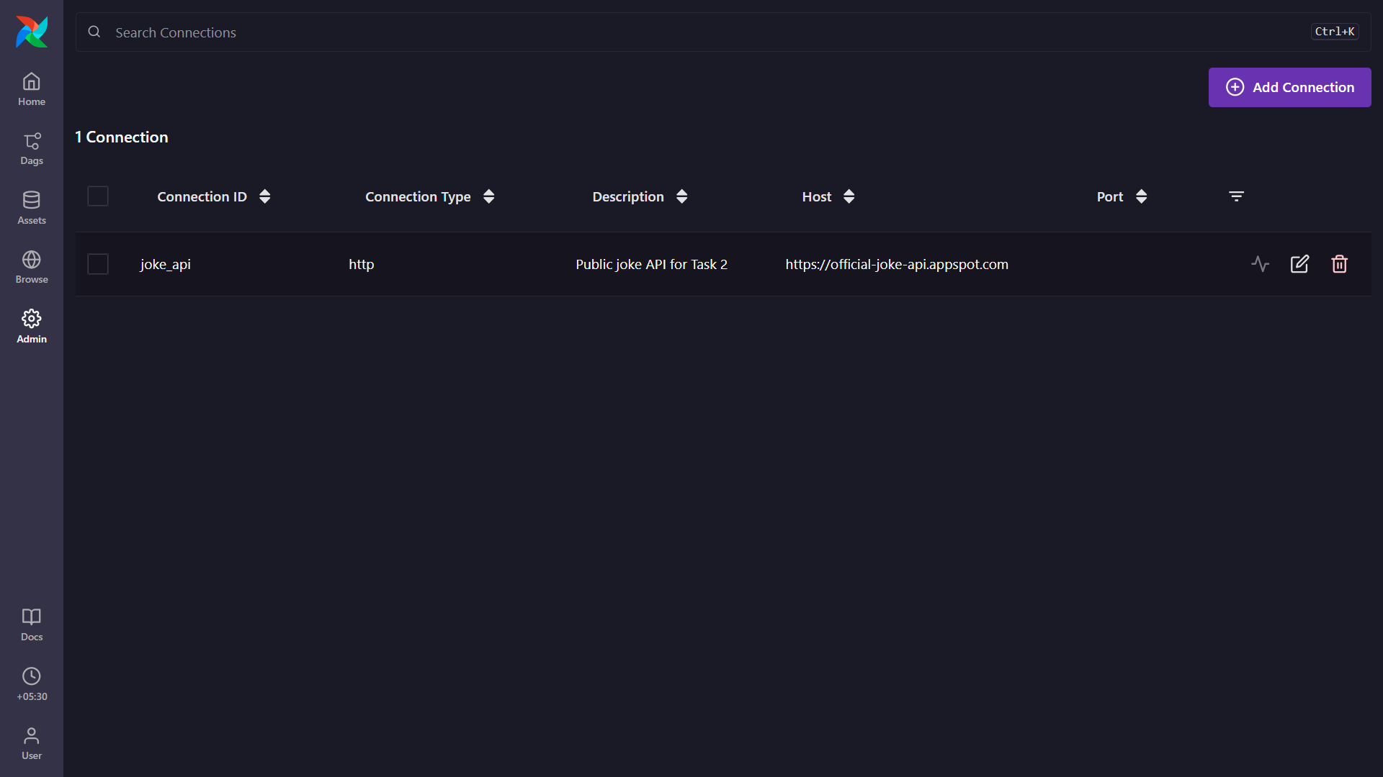

- Graph View — all 3 tasks GREEN: get_random_joke → get_ten_jokes → show_results
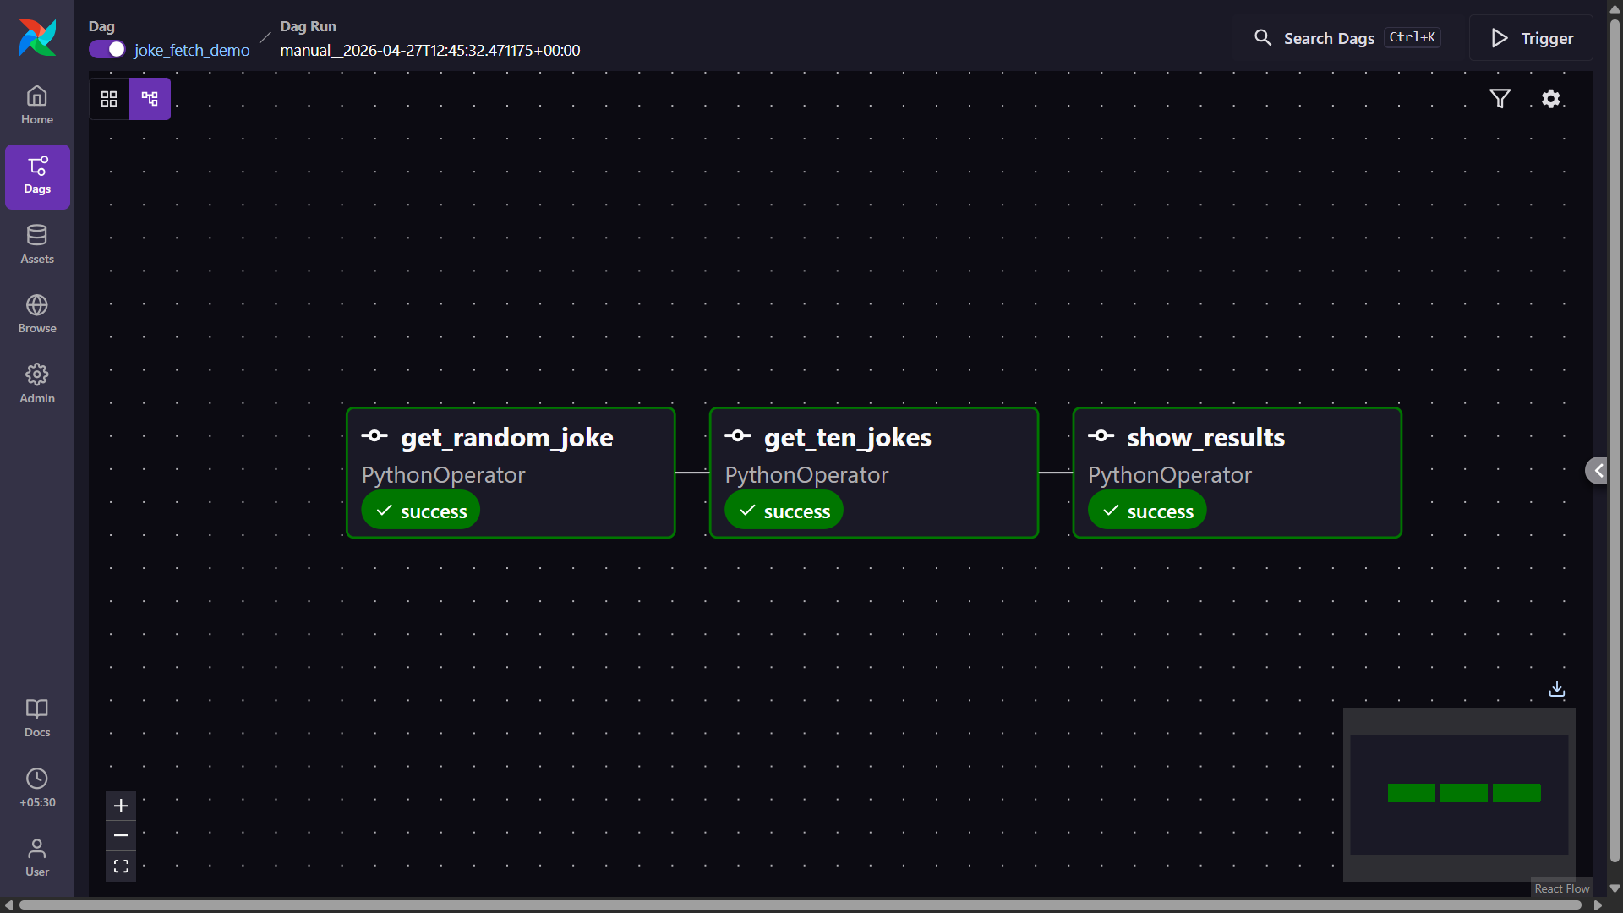
- Task Log of get_random_joke — showing the joke type, setup, and punchline printed
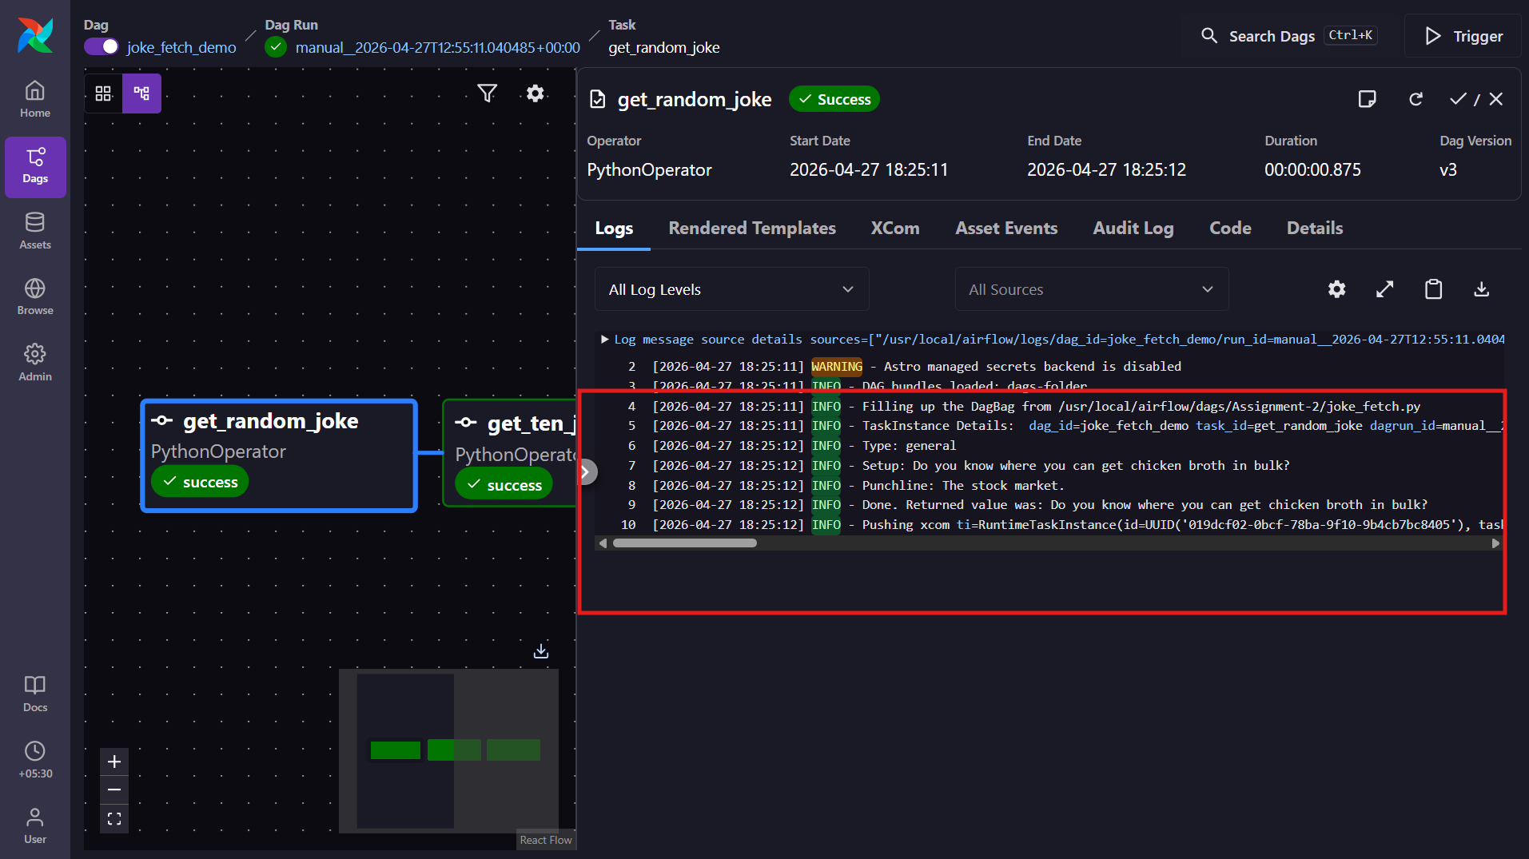

- Task Log of show_results — showing the combined totals and the "no URL" confirmation line
